**PET is Wonderful-Chan Zuckerberg Initiative Summer Scholarship**

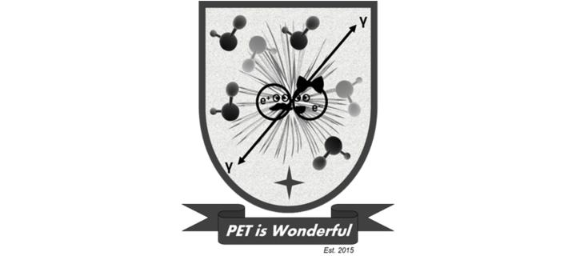 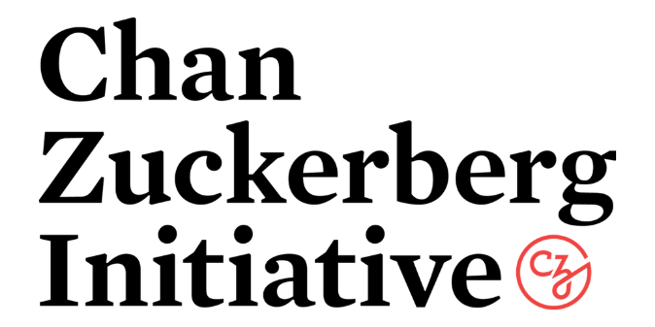

**Application Form 2024/2025**

**Description of scholarship**

Each successful researcher candidate may be the recipient of a **single award only**, up to a maximum value of **$8,100** (funds will be paid by the University of Edinburgh in GBP and conversion rates apply at the time of award). Eligible costs are restricted to economy travel and subsistence at the agreed institutional rate.

Each summer scholarship must be for a **maximum of 12 consecutive weeks** anytime between 1st of June and 30th of September of each year.

This project has been made possible in part by a grant from the Chan Zuckerberg Initiative DAF, and advised fund of Silicon Valley Community Foundation.

**\*\*\* The deadline for submission of applications is 31st December 2024**

**Purpose**

The main purpose of the funding is to provide research training and development opportunities for researchers from anywhere in the globe that are seeking to learn more about medical imaging with particular focus on Positron Emission Tomography (PET) imaging.

**Eligibility**

One summer scholarship will be competitively awarded annually to one student, technician or post-doctoral researcher within 10 years of their PhD award (i.e. early career researcher) looking to learn more about *in vivo* PET imaging techniques.

**Terms and Conditions**

The summer scholarship proposals will be assessed by a panel of PET experts and the successful applicant will be invited to received “hands-on” training in the core imaging PET facility in Edinburgh, Scotland.

Criteria for selection will include:

1. evidence of the ability of the candidate (output, leadership);
2. likely benefits to the research of the candidate (new skills, techniques likely to be acquired) as result of the summer scholarship;
3. likely benefits to the longer-term career of the researcher as result of the summer scholarship;
4. evidence of wider benefits to the research community at the applicant’s institution and research community (local, national, and international); and
5. prospects of sustained dissemination of new imaging skills from the applicant to their immediate research community post-summer scholarship. We are looking to maximize impact of this summer scholarship on research communities worldwide.

Each successful candidate will be required to enter into an appropriate agreement with the University of Edinburgh.

A two page report will be required at the end of the summer scholarship.

**Application form**

|  |  |
| --- | --- |
| Name and contact details of candidate [address, phone number and email] |  |
| Short candidate background and resume description [<200 words] |  |
| Candidate experience in PET imaging, or, if not applicable, why interest in learning more about PET imaging? [<200 words] |  |
| Evidence of the ability of the candidate (research output, leadership) [<200 words] |  |
| Likely benefits to the research of the candidate (new skills, techniques likely to be acquired) as result of the summer scholarship  [<200 words] |  |
| Likely benefits to the longer-term career of the researcher as result of the summer scholarship [<200 words] |  |
| Evidence of wider benefits to the research community at the applicant’s institution, research community and country [<200 words] |  |
| Estimate of expenditure (itemised) |  |
| Proposed time and length of visit (max. 12 consecutive weeks between 1st June and 30th September) |  |

Please send complete application form to [piwteam@ed.ac.uk](mailto:piwteam@ed.ac.uk). Application outcome will be communicated by mid-March 2025.